

**HOSPITAL MANAGEMENT SYSTEM**

**Course Code:CSE134**

**Course Title:Data Structure Lab**

**Submitted TO :**

**Rishad Amin Pulok**

Lecturer

Department of Computer Science & Engineering

Metropolitan University, Bangladesh

**Submitted By:**

**Prity Saha Chnoya**

ID No: 232-115-321

**Farhana Nowshin**

ID No: 232-115-322

**Adrita Chakraborty**

ID No: 232-115-324

Batch:59

Section:I

**Date of Submission:** 12/11/2024

Introduction:

The **Hospital Management System (HMS) for PAF Healthcare Hospital** is a comprehensive and centralized software solution designed to streamline the core operations of a multispecialty hospital. It efficiently manages patient registration, appointments, staff coordination, billing, and room availability. Each patient is assigned a unique ID, enabling quick access to medical records and doctor schedules. The system enhances hospital efficiency, reduces human error, and ensures secure data handling through a protected login mechanism. With its user-friendly interface and fast data processing capabilities, HMS supports effective decision-making, improves patient care, and lays a solid foundation for future growth and scalability.

Background Study:

The Hospital Management System (HMS) for PAF Medical Healthcare Hospital was developed to automate and streamline operations.

**Key Resources :**

* **Online Platforms:** Google, Stack Overflow, GitHub for coding support.
* **Learning Materials:** YouTube for C programming concepts.
* **Books:** Software development and hospital systems for theoretical knowledge.
* **Mentor Guidance:** Insights from a healthcare IT expert.

**Team Collaboration :**

Our team's efforts ensured the system was practical, efficient, and tailored to meet the hospital's specific needs.[1][2][3]

Features:

1. User Authentication and Access Control: 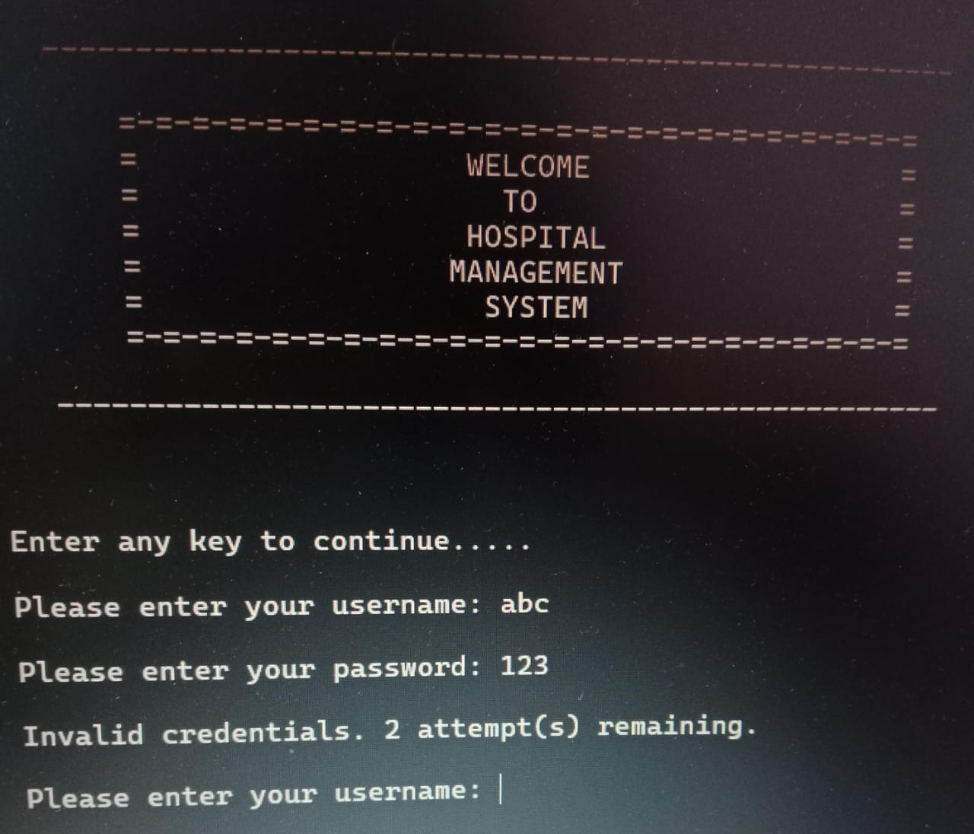

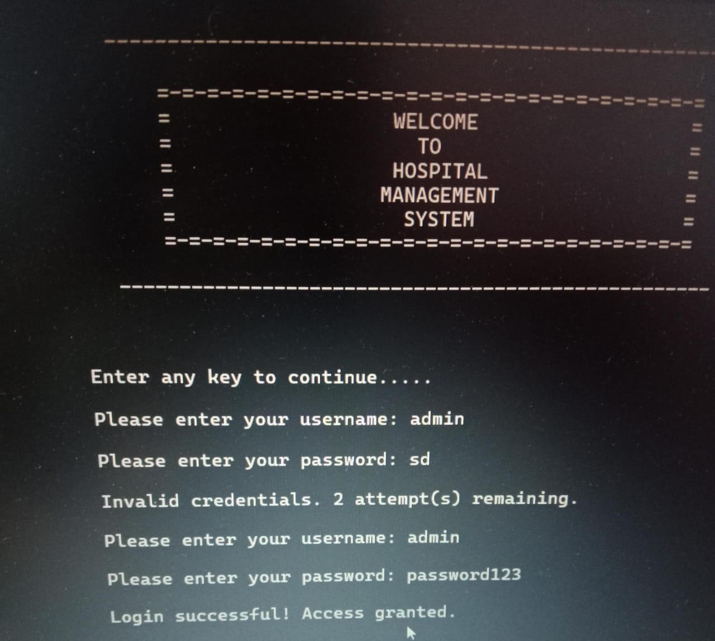

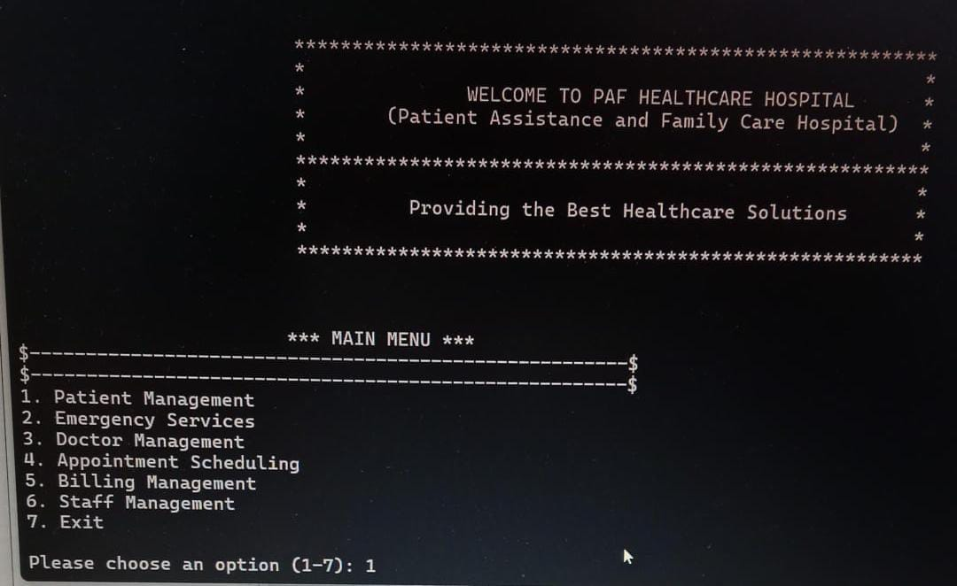

2.Patient Management:

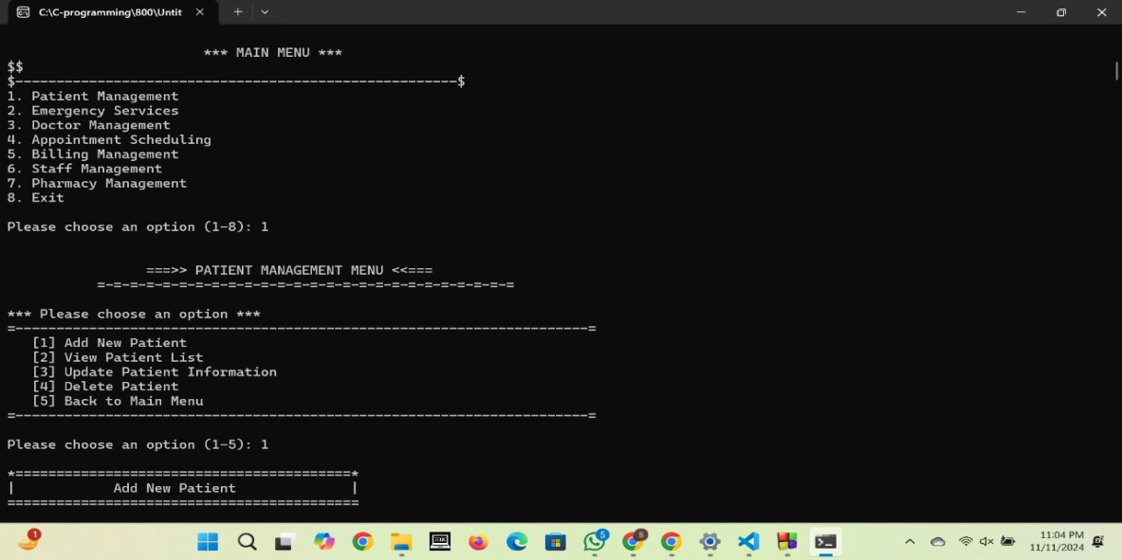

(i)Add New Parient

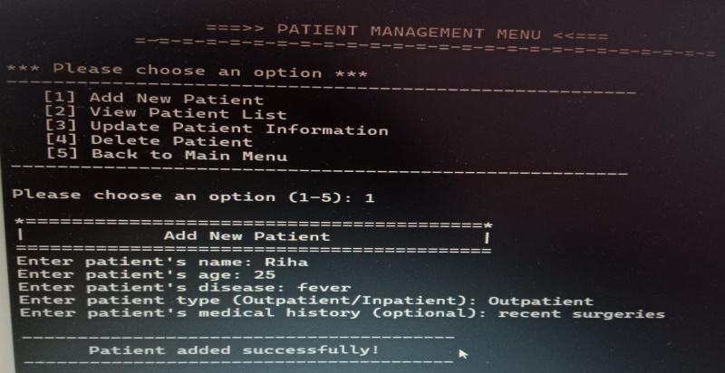

(ii)Veiw Patient List:

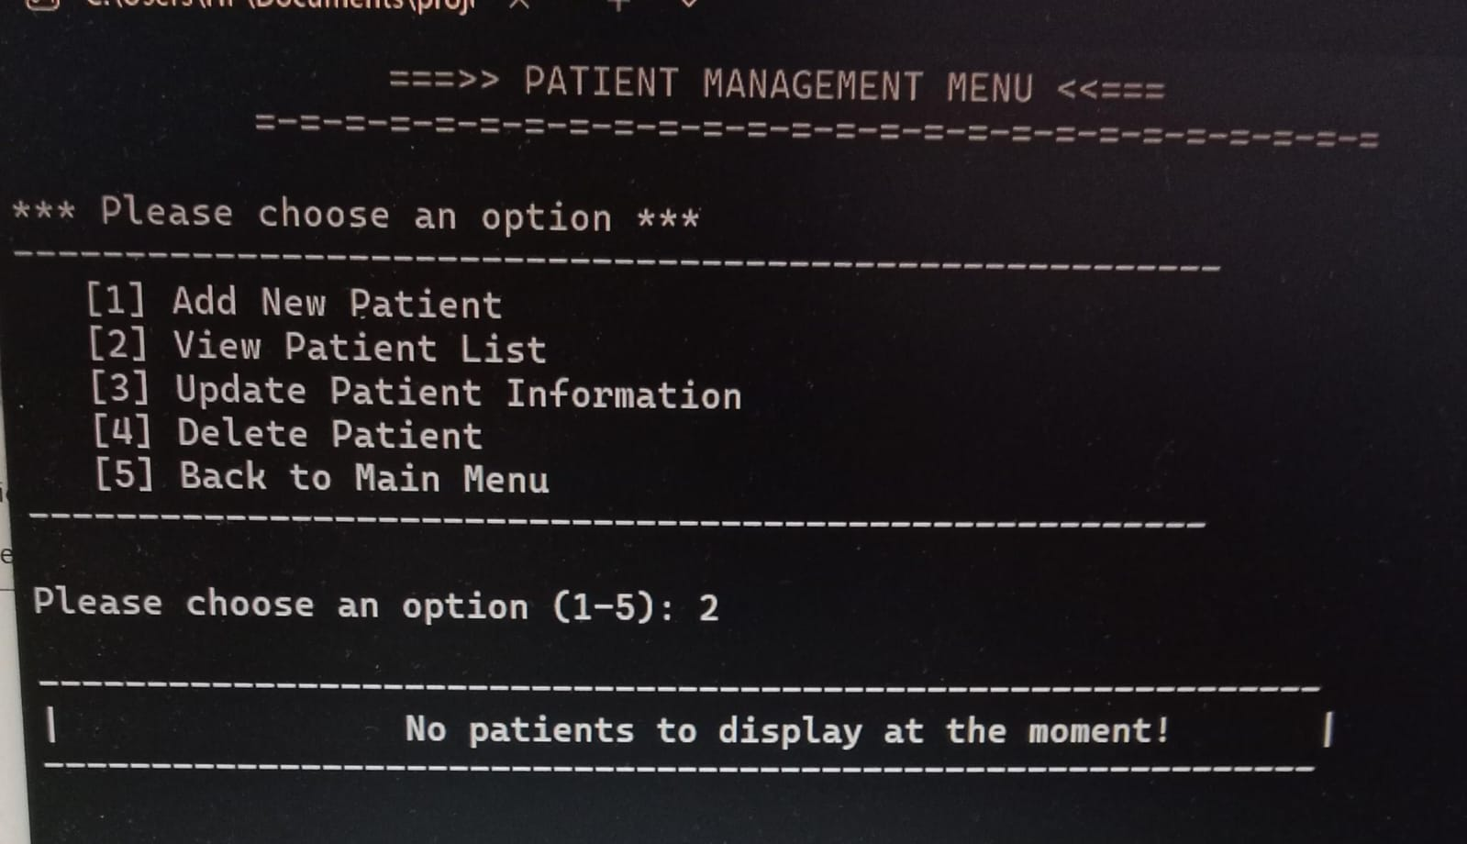

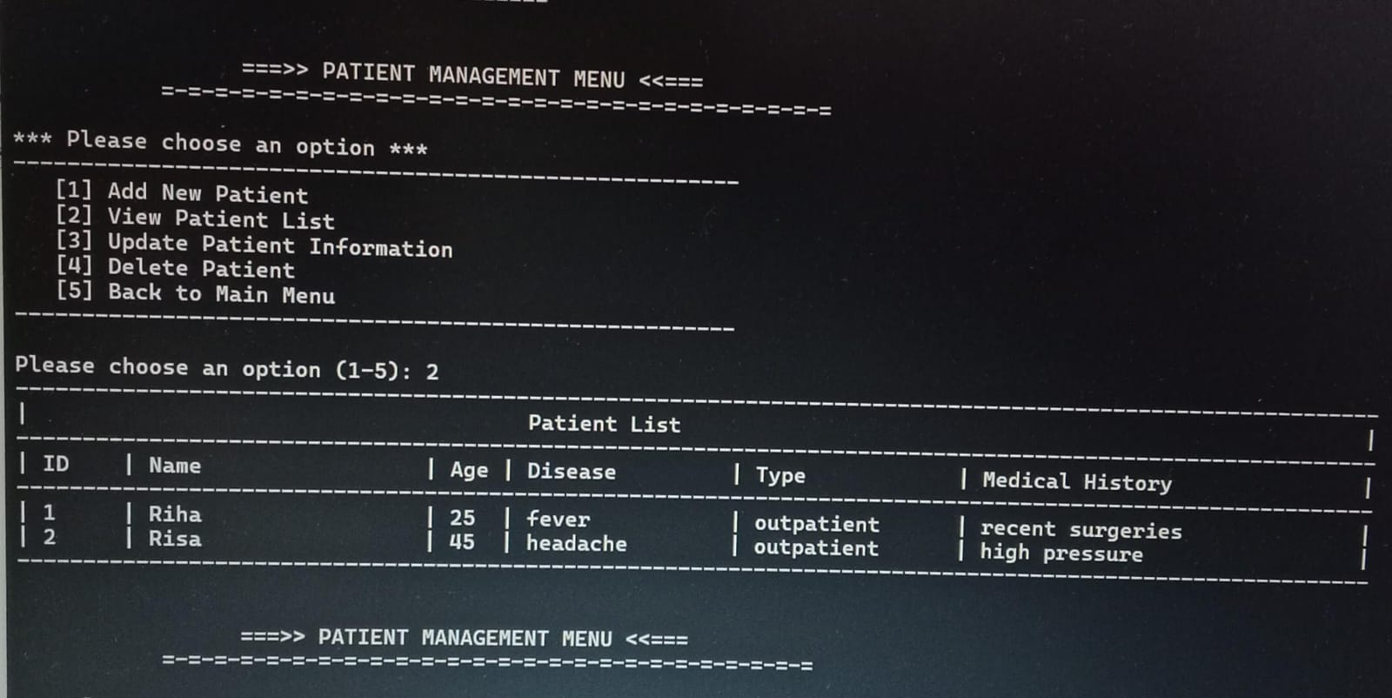 (iii)Update patient Information:

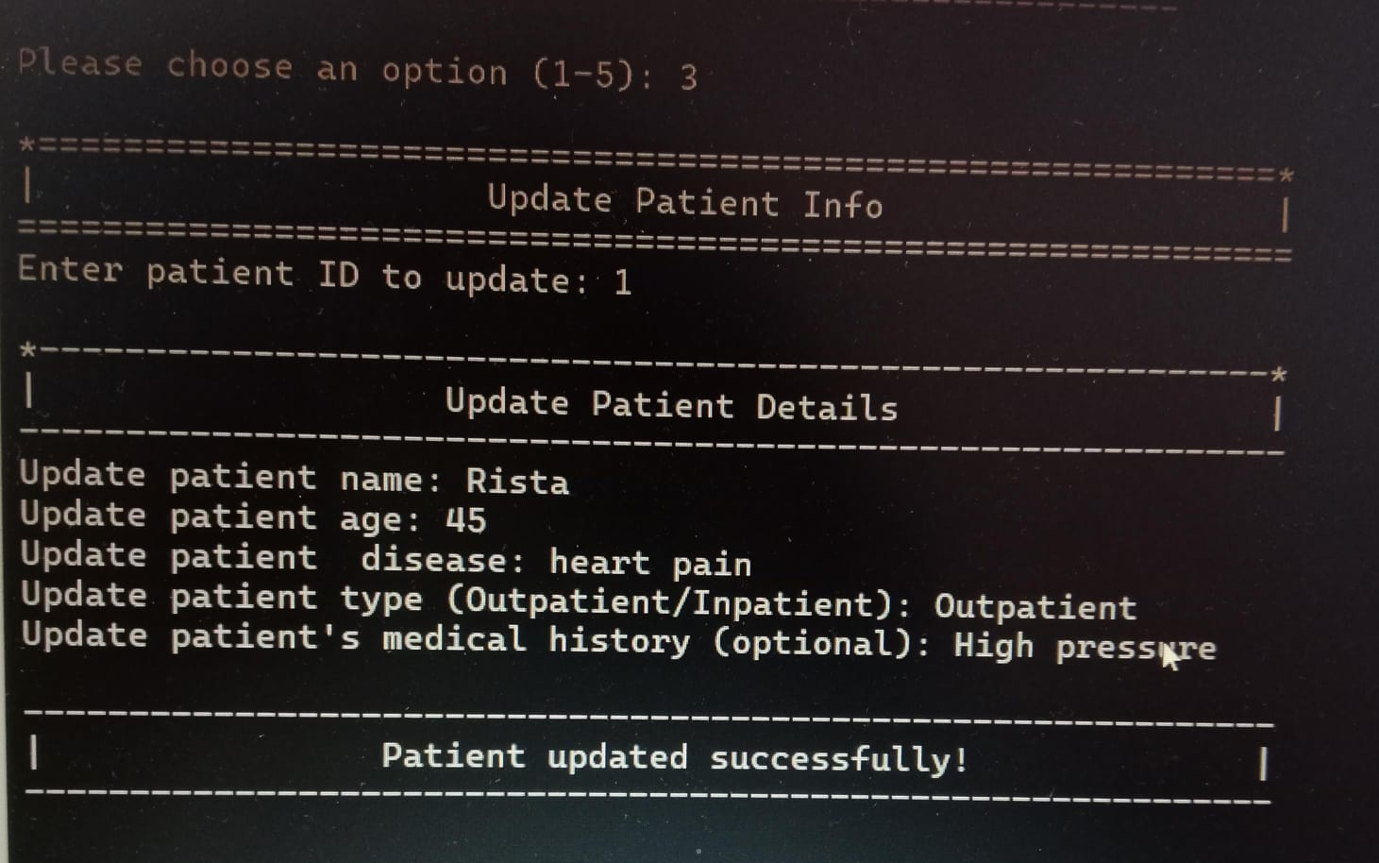(iv).Delete Patient:

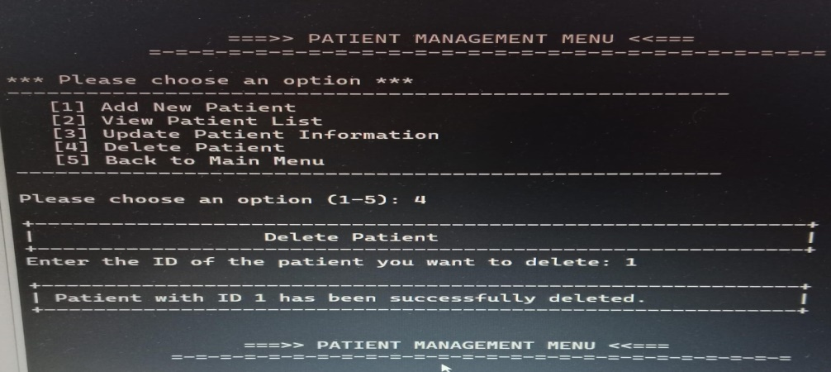

3.Emergency Services:

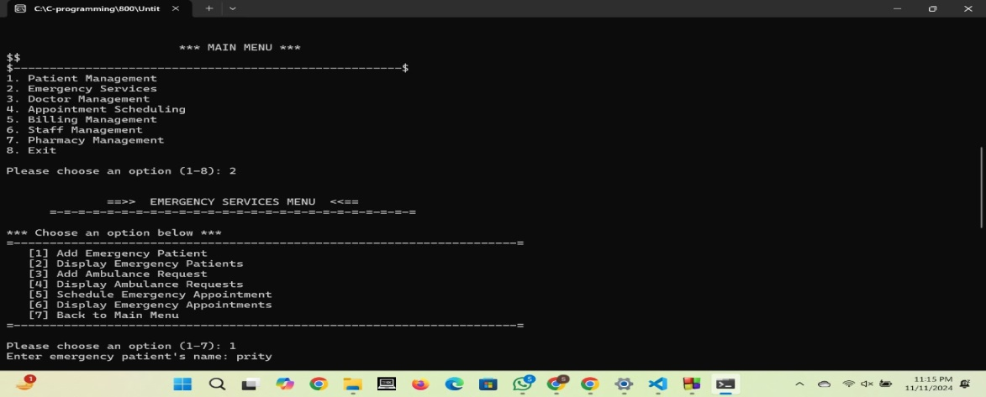

(i)Add Emergancy Patient:

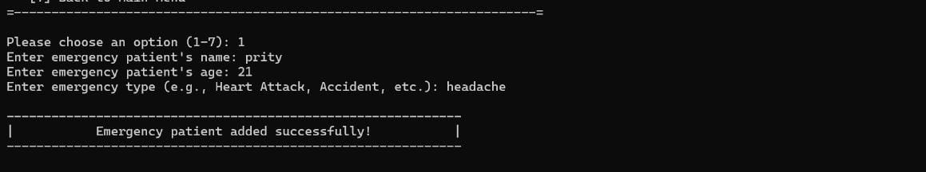

(ii)Display Emergency Patients:

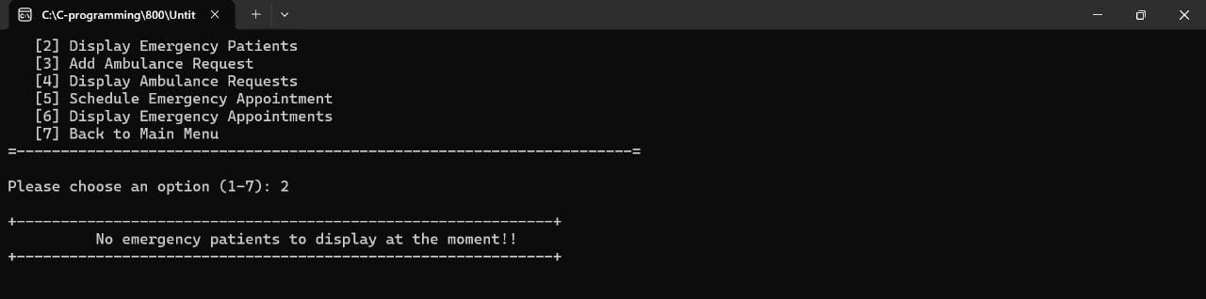

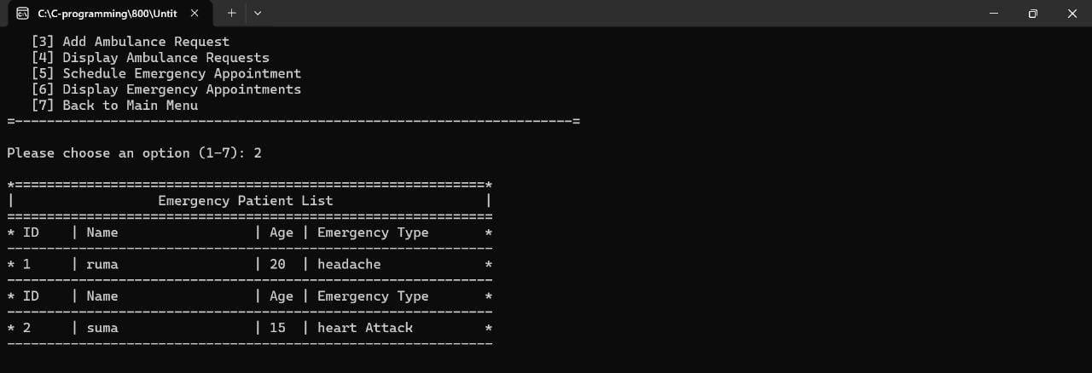

(iii)Add Ambulance Request:

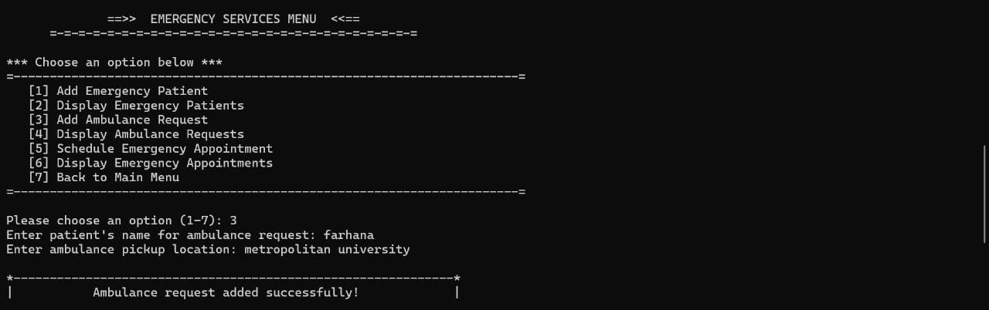

(iv)Display Ambulance Request:

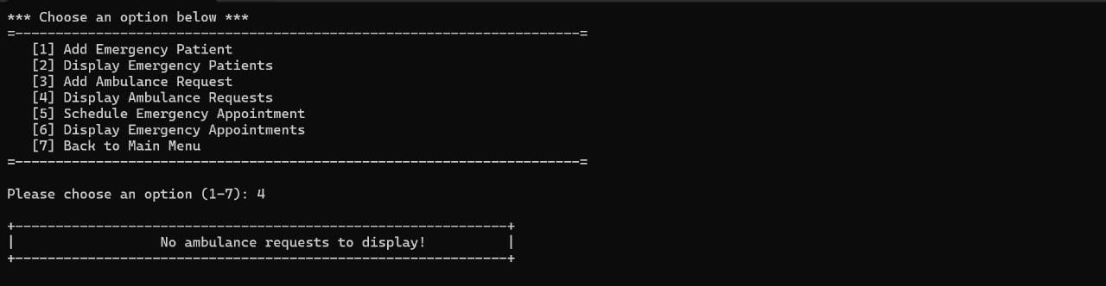

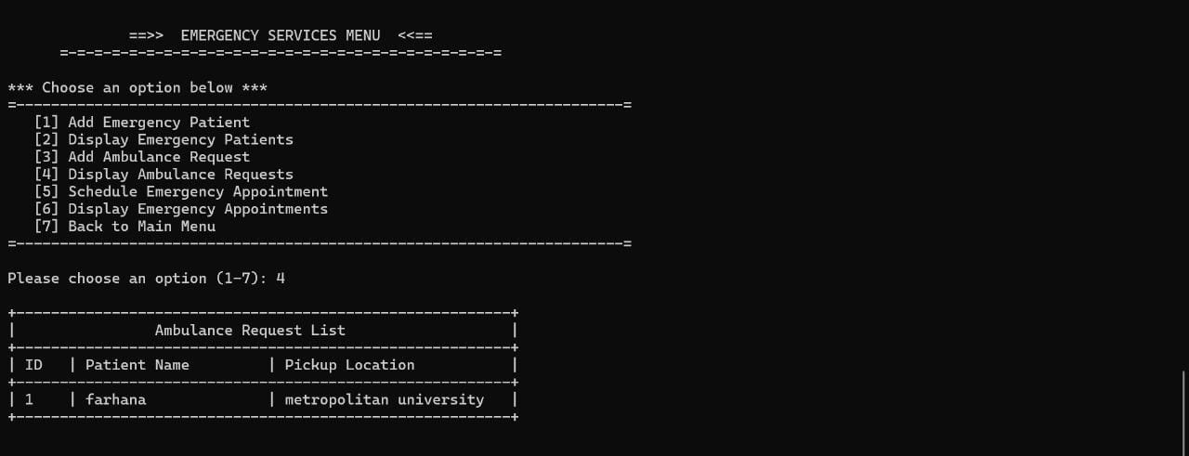

(v)Schedule Emergency Appointment:

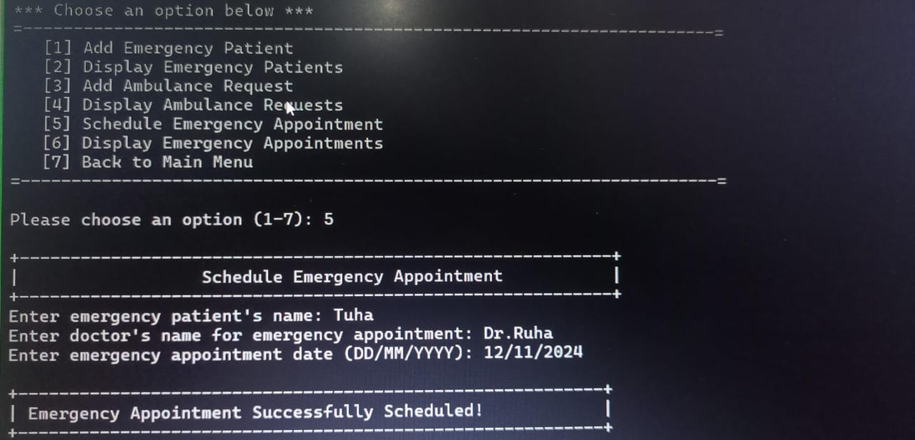

(vi)Display Emergency Appointments:

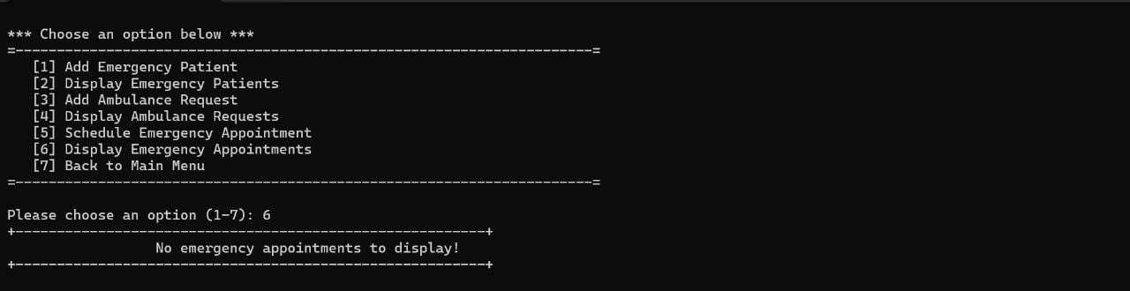

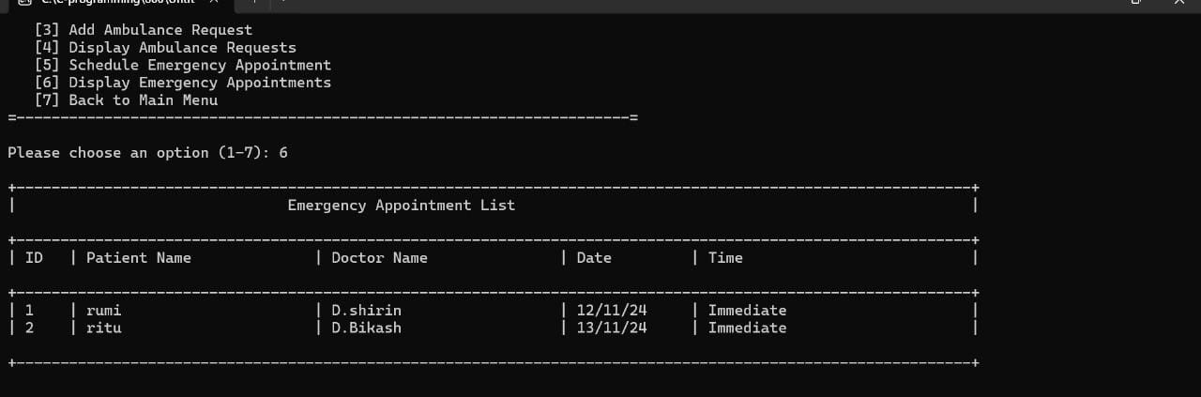

4.Doctor Management:

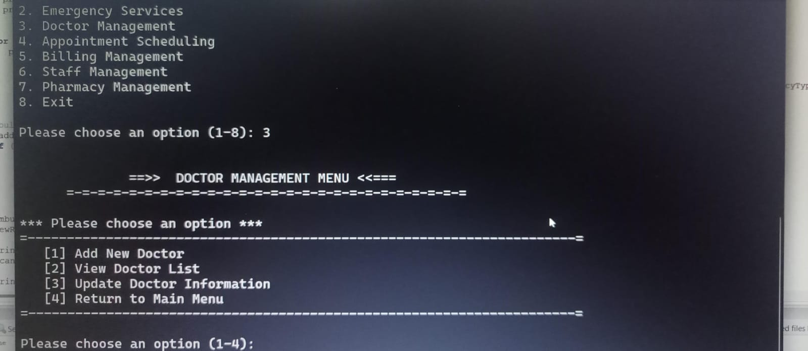

(i)Add New Doctor:

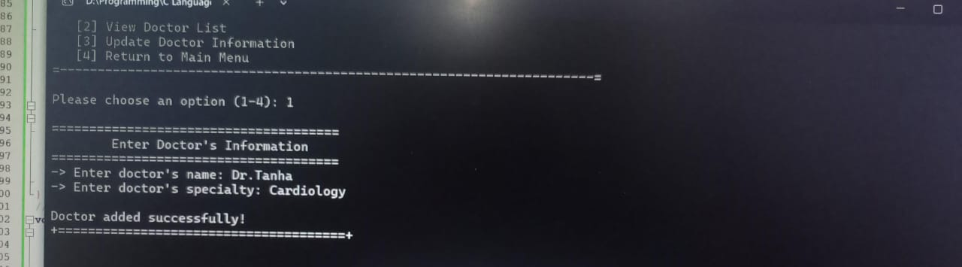

(ii)View Doctor List:

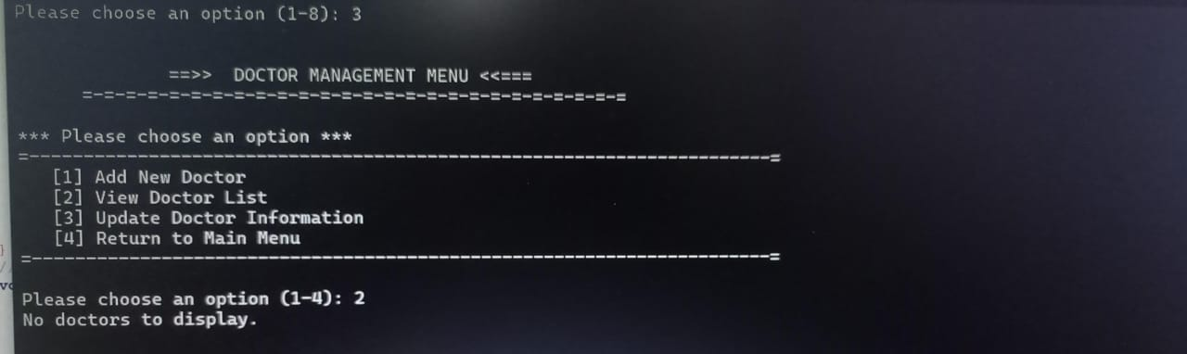

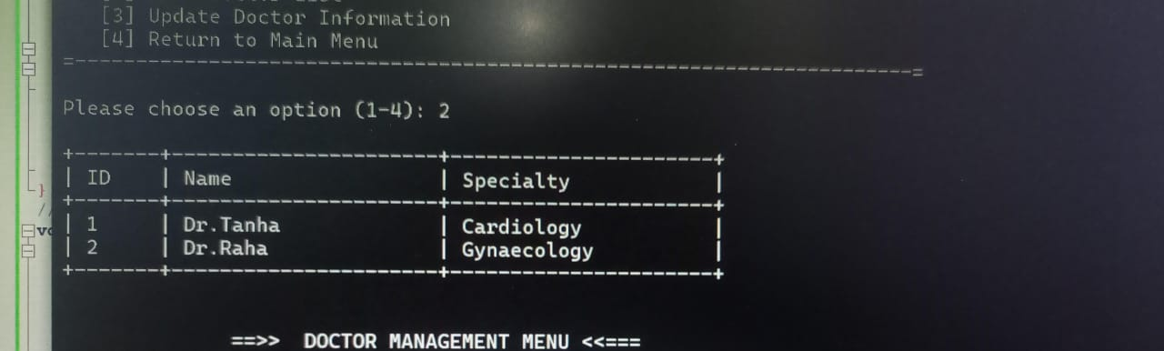

(iii)Update Doctor Information:

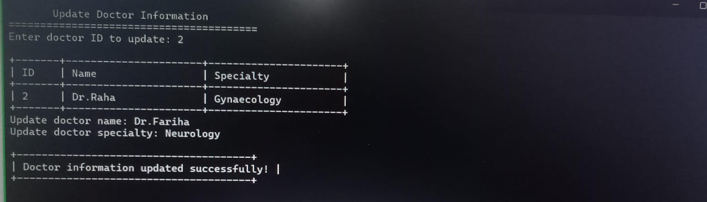

5.Appintment Scheduling:

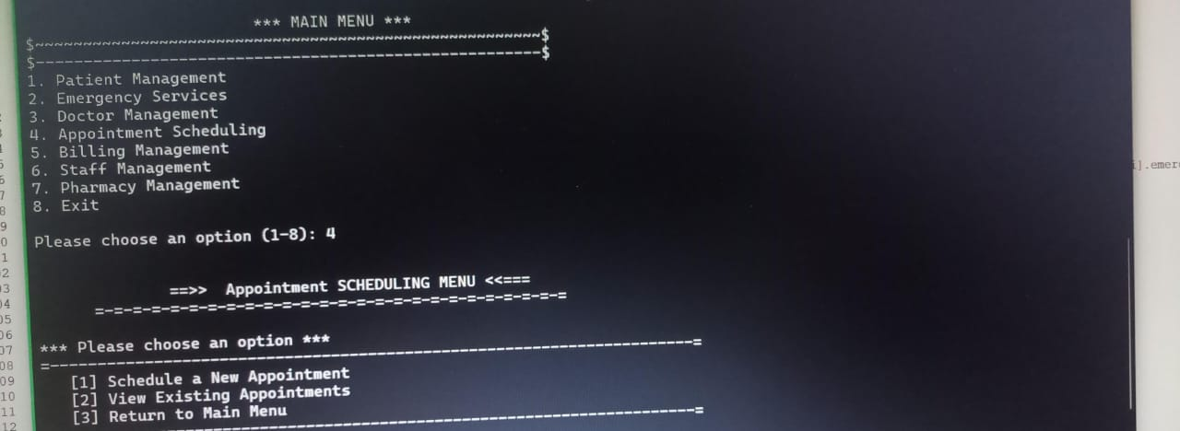

(i)Schedule a New Appointment:

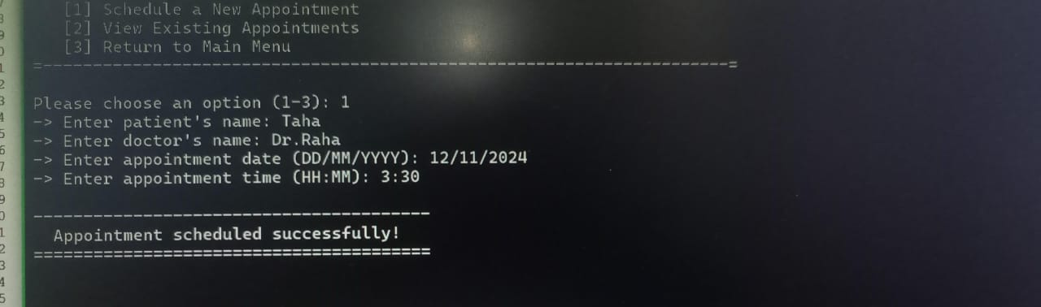

(ii)View Existing Appointment:



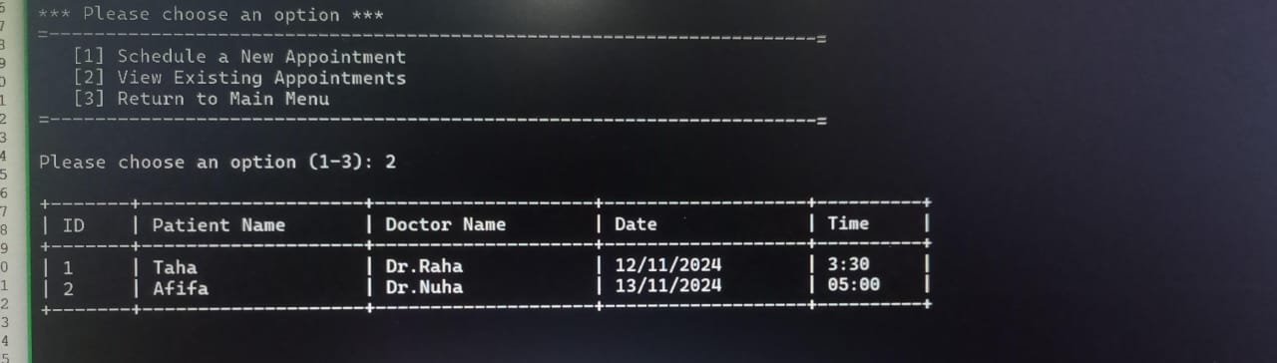

6.Billing Management:

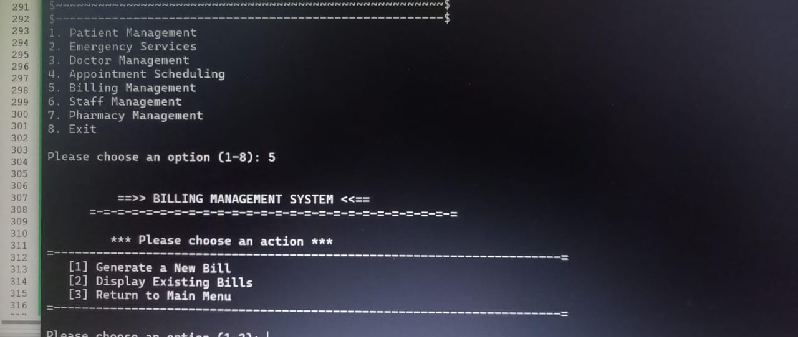

(i)Generate a New Bill:

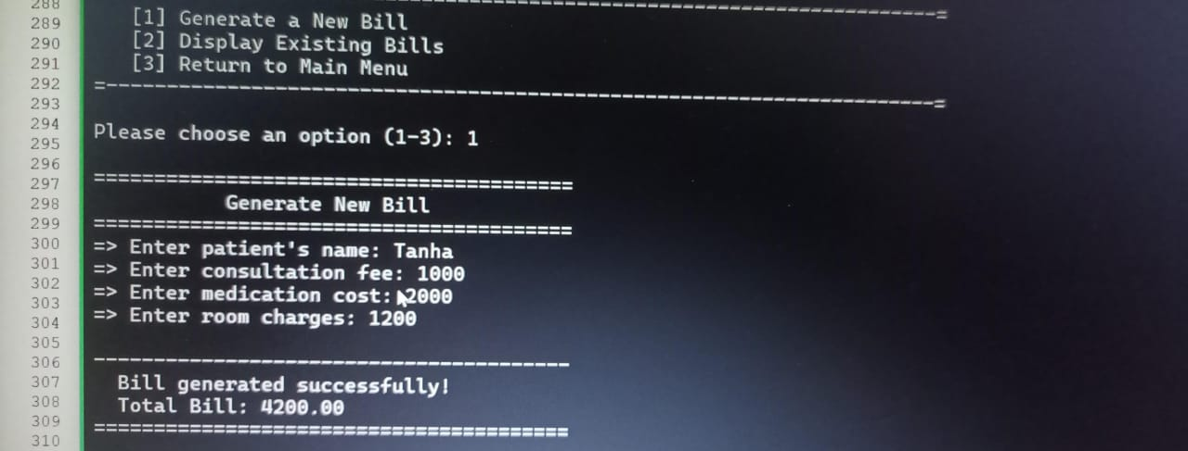

(ii)Display Existing Bills:



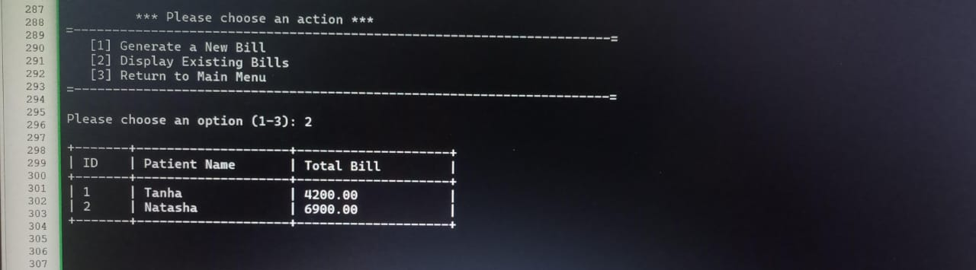

7.Staff Management:

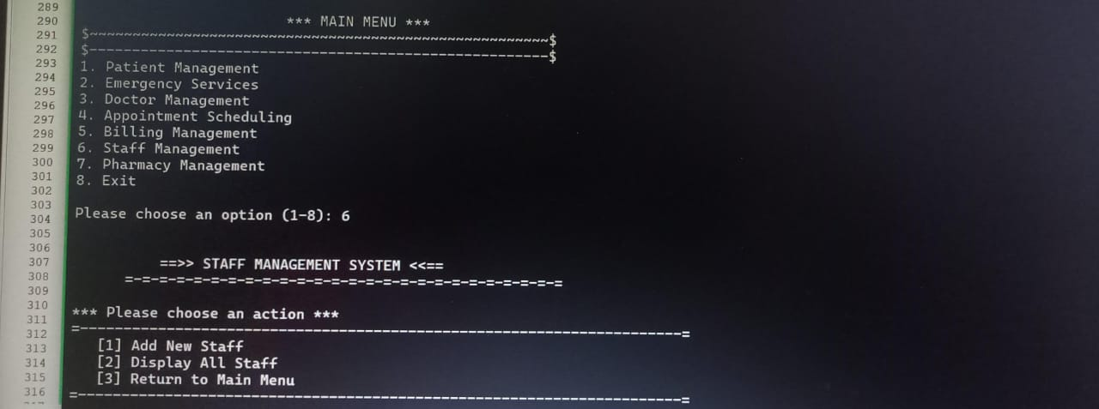

(i)Add New Staff:

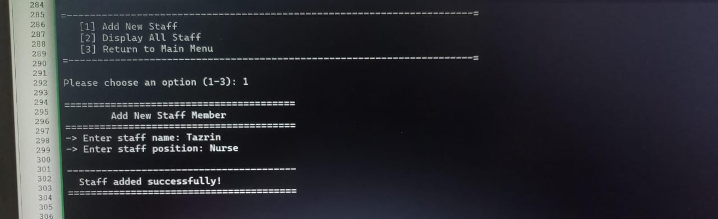

(ii)Display All Staff:

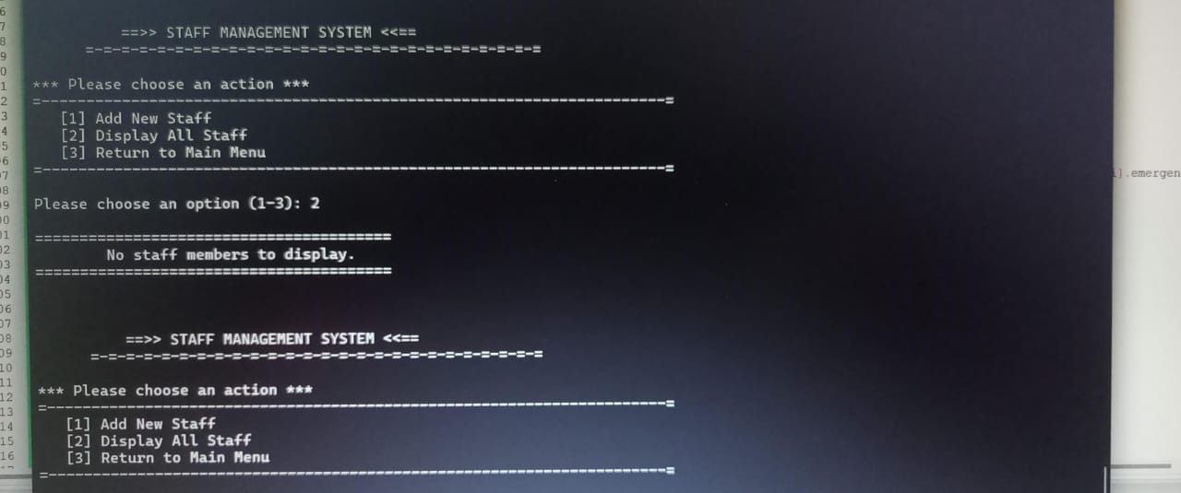



8.Pharmacy Management:

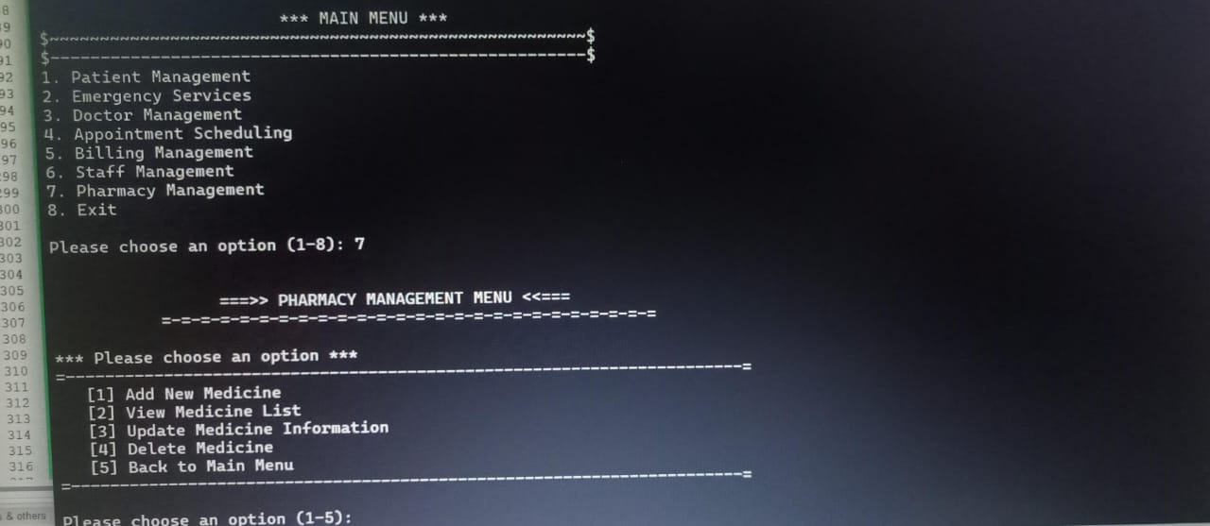

(i)Add New Medicine:



(ii)View Medicine List:

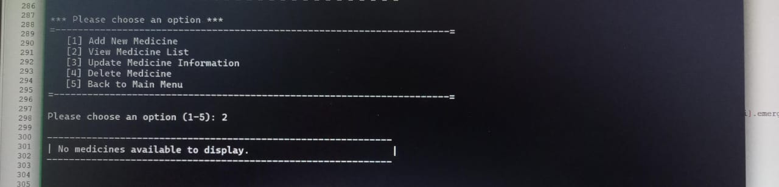

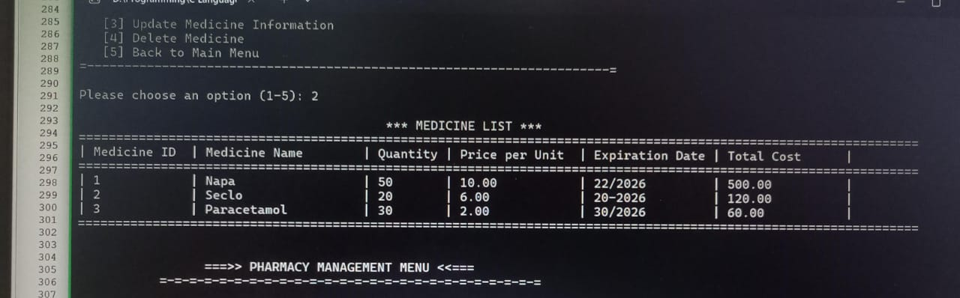

(iii)Update Medicine Information:

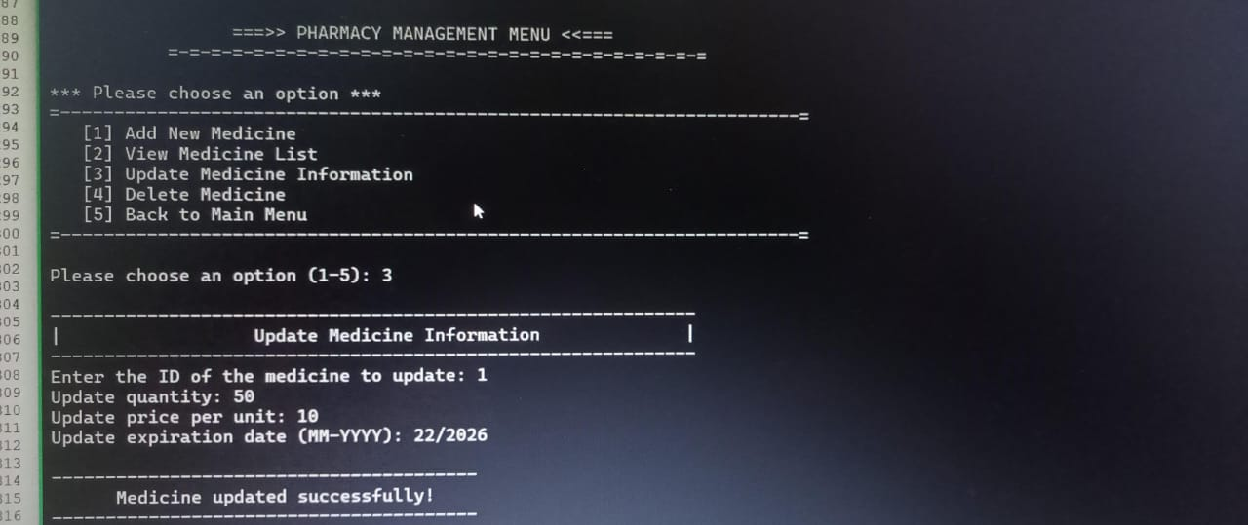

(iv)Delete Medicine:

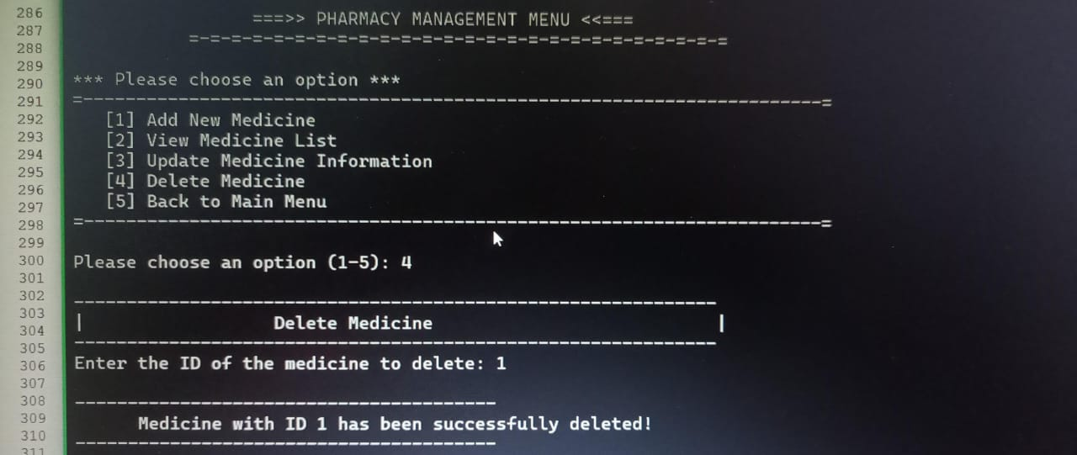

Limitations:

* **Complexity**:

Implementing a full-fledged HMS is complex and needs careful planning.

* Cost :

Developing and implementing an HMS can be expensive.

* **Technical Expertise**:

A skilled IT team is essential for maintenance.

* **Security**:

Strong security measures are crucial to protect patient data.

* **System Integration**:

Integrating with existing systems can be challenging.

* **Array Size Problem**:

The system can only hold a certain number of things like patient records, doctor info, and appointments. This can make it slow and lead to mistakes. Using a database would be better.

By understanding these limitations and carefully planning the implementation process, healthcare organizations can mitigate risks and maximize the benefits of an HMS.

Future scope:

* Lab Integration: Automate test requests and results.
* Tourist Patient Support: Multi-language and international billing.
* Mobile App: Remote access for doctors and patients.
* Smart Analytics: Optimize operations and patient care.
* Improved Data Storage: Secure and efficient data management.
* Cloud-Based: Scalable and accessible real-time system.

Conclusion:

The PAF Medical Healthcare Hospital's HMS is a significant step towards modernizing healthcare operations. By automating tasks, streamlining workflows, and improving data management, the HMS enhances patient care, operational efficiency, and overall hospital performance. Future advancements in technology, such as AI and machine learning, can further optimize the system and elevate the hospital's standing in healthcare.

1. <https://sg.docworkspace.com/d/sIACHhaKPAqvvvLkG?sa=601.1123&ps=1&fn=Hospital%20Managment%20Project%20SE-converted.pdf>
2. <https://search.app?link=https%3A%2F%2Fwww.researchgate.net%2Fpublication%2F380505845_Hospital_Management_System_Project_Report&utm_campaign=aga&utm_source=agsadl2%2Csh%2Fx%2Fgs%2Fm2%2F4>
3. <https://search.app?link=https%3A%2F%2Fwww.geeksforgeeks.org%2Fc-program-for-hospital-management-system%2F&utm_campaign=aga&utm_source=agsadl2%2Csh%2Fx%2Fgs%2Fm2%2F4>